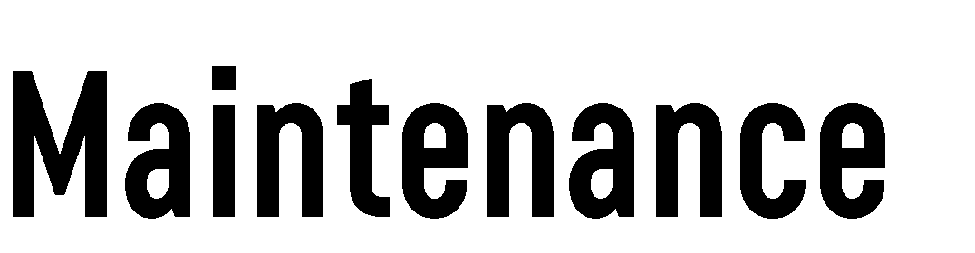 |  |  |  |  | PASS
 |  |  |  |  | (Pre-Job Area Safety Survey)
Instructions:
- Prior to beginning any work pertaining to upset conditions, non-routine work tasks, lockouts or any task where no task specific work procedure exists, complete this survey. The survey can be displayed in the work area or held on your person until the job/task is completed.
- When work is completed or before leaving at the end of your shift, return the completed survey to your supervisor or drop box.
Date: |  | Time: | Shift:
Start of Shift Task Specific | □  □ | Sawmill □ Planer □ Yard □ Other □:
Employee(s):
Job/Task Location:
Job/Task of Work Performed:
Scope of Work: HIGH RISK WORK ACTIVITY REQUIRES INCREASED FREQUENCY OF INSPECTIONS!
High Risk Work Activity
Lockout ☐ Hot work ☐ Confined Space ☐ Work at Height >10’ ☐ >25’ ☐ Hoisting/Rigging ☐ Crane Use ☐ Excavation ☐
Energized Equipment ☐ Mobile Equipment ☐ Aerial Work Platform ☐ Potential to Contact Overhead Powerlines ☐
Inspections and Site Conditions
PPE: Required Basic PPE □ Specialty PPE □ |  |  |  | Good Condition □ Clean □
Work Area: Adequate Lighting? Yes □ No □ Area Clean (dust/debris): Yes □ No □ Other workers in the area? Yes □ No □
Anything Changed? Yes □ No □
Standing Surface: Flat □ Sloped □ Uneven/Obstacles □ Slippery □ Ladders/Stairs □
Tools: Hand Tools □ Power Tools □ Lifting Device □ Rigging □ Ladder □  Electrical Cords □ Ground Fault Interrupters (GFI) □ Other □: |  |  |  |  | Good Condition □ Clean □
Fall Protection: Harness □ Lanyard □ Anchor □ Guardrail □  Control Zone □ Ladder tied off □ |  |  |  |  | Good Condition □ Clean □
Equipment: Forklift □ Skid Steer □ Aerial Platform (Boom/Scissor) □ Crane □ |  |  |  |  | Good Condition □ Logbook □
Permits/Forms: Confined Space □ Crane Field Assessment □ Electrical PASS Card □ Excavation □ Live Equipment Process □
Mobile/Equipment Pre-Trip Form □ Electrical Work Permit □ Hot Work Permit □ Fall Protection Plan (>25’ Fall) □

Hazards Identification and Control
Ergonomics |  | Detail/Description |  | Actions and Controls
Repetitive Strains
Over Extension/ Exertion
Body Position |  | Comfortable □ Awkward □  Work above Head □
Weight / Lifting  (Heavy/Awkward) |  | <50lbs □ 50-80lbs □ >80lbs □ |  | 1 Person □ 2 Person□ Leverage □ Lift device□
Other:
Have You Considered These 4 Critical States?  1. Rushing 2. Fatigue  3. Frustration 4. Complacency |  |  | Have you Considered These 4 Critical Errors?  1. Eyes not on Task 2. Mind not on task  3. In the line of fire 4. Poor balance, traction, grip
Physical |  | Detail/Description |  | Actions and Controls
Slip/Trip/Fall
Cut by Sharp Edges
Projectiles/Flying Debris
Overhead/Suspended
Struck by or against |  |  |  | Hands Free □ Body Clear □
Fall From Height |  | □ <10ft □>10ft □ >25ft
Combustible Dust
People |  | Operator □ Supervisor □ Co-Worker □ |  | Control Zone □ Signage □  Verbal Communication □
Energy Sources |  | Electrical □ Hydraulic □ Air □  Gravity □ Rotation/Kinetic □
Working Alone/ Isolation
Other:
Are there any tools or processes that would make this job/task easier or more efficient?
Ask yourself: What are the hazards? How can I protect myself and others?
Help | Do I need help? Am I trained? Who is going to help me?
Surroundings | What is my 10’ circle of danger? Falls, trips, falling material, energy sources.
Standing | What am I standing on? Is it stable, free of debris, slippery, too small?
Tools | Am I using the proper tool for the job? Am I using it correctly? Is it in good condition?
People | Anyone else in the area? Did I communicate my work activity to them?
Breaks Free | Is there a pinch point, or bite zone of the equipment? What tool can slip and hit me? Are there boards under tension? If it  breaks free, where will it hit me?
Weight | How much weight am I dealing with? What is the best way to lift it? Do I need help or a lifting device?
Position | What position is my body in? Is it awkward? In the line of fire? Is there potential for repetitive strain?
PPE | Do I have the right PPE for the task? Is it in good condition?
Lockout | Have I considered all the energy sources? Have I secured locks to all the required locations? Are all lockout tests completed?
Supervisor Review/Comments (i.e. Feedback, additional hazards, concerns, or controls identified during review)
Controls/Solution/Action = What actions did you take to fix it or make it safer?

