Original PDF from EAO 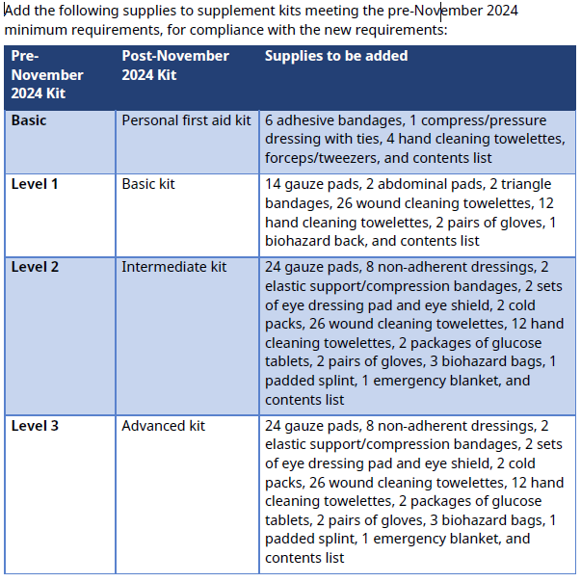

BCFSC Transcription into Word
Add the following supplies to supplement kits meeting the pre-November 2024 minimum requirements, for compliance with the new requirements:
Pre-  Nov 2024 Kit | Post-November  2024 Kit | Supplies to be added to each kit
Basic | Personal first aid kit | - 6 adhesive bandages  - 1 compress/pressure dressing with ties  - 4 hand cleaning towelettes  - forceps/tweezers  - revised contents list
Level 1 | Basic kit | - 14 gauze pads  - 2 abdominal pads  - 2 triangle bandages  - 26 wound cleaning towelettes  - 12 hand cleaning towelettes  - 2 pairs of gloves  - 1 biohazard bag  - revised contents list
Level 2 | Intermediate kit | - 24 gauze pads  - 8 non-adherent dressings,  - 2 elastic support/compression bandages  - 2 sets of eye dressing pad and eye shield  - 2 cold packs  - 26 wound cleaning towelettes  - 12 hand cleaning towelettes  - 2 packages of glucose tablets  - 2 pairs of gloves  - 3 biohazard bags  - 1 padded splint  - 1 emergency blanket  - revised contents list
Level 3 | Advanced Kit | - 24 gauze pads  - 8 non-adherent dressings  - 2 elastic support/compression bandage  - 2 sets of eye dressing pad and eye shield  - 2 cold packs  - 26 wound cleaning towelettes  - 12 hand cleaning towelettes  - 2 packages of glucose tablets  - 2 pairs of gloves  - 3 biohazard bags  - 1 padded splint  - 1 emergency blanket  - revised contents list

